Overview: The Keyboard and Mouse

If you think of the CPU as a computer’s brain, then you might think of the input devices as its sensory organs—the eyes, ears, and fingers. From the user’s point of view, input devices are just as important as the CPU, perhaps even more important. After you buy and set up the computer, you may take the CPU for granted because you interact directly with input devices and only indirectly with the CPU. But your ability to use input devices is critical to your overall success with the whole system. An input device does exactly what its name suggests: it enables you to enter information and commands into the computer. The most commonly used input devices arc the keyboard and the mouse. If you buy a new personal computer today, it will include a keyboard and mouse unless you specify otherwise. Other types of input devices arc available as well, such as variations of the mouse and specialized ''alternative” input devices such as microphones and scanners. This lesson introduces you to the keyboard and the mouse. You will learn the importance of these devices, the way the computer accepts input from them, and the many tasks they enable you to perform on your PC.

OBJECTIVES:

* Identify the five key groups on a standard computer keyboard.
* Name six special purpose keys found on all standard computer keyboards.
* List the steps a computer follows when accepting input from a keyboard.
* Describe the purpose of a mouse and the role it plays in computing.
* Identify the five essential techniques for using a mouse.
* Identify three common variants of the mouse.
* Describe five steps you can take to avoid repetitive stress injuries from computer use.

**The Keyboard**

The keyboard was one of the first peripherals to be used with computers, and it is still the primary input device for entering text and numbers. A standard keyboard includes about 100 keys; each key sends a different signal to the CPU. If you have not used a computer keyboard or a typewriter, you will learn quickly that you can use a computer much more effectively if you know how to type. The skill of typing, or keyboarding, is the ability to enter text and numbers with skill and accuracy. Certainly, you can use a computer without having good typing skills. Some people claim that when computers can interpret handwriting and speech with 100 percent accuracy, typing will become unnecessary. But for now and the foreseeable future, keyboarding remains the most common way to enter text and other data into a computer:

**The Standard Keyboard Layout**

Keyboards come in many styles. The various models differ in size, shape, and feel; except for a few special-purpose keys, most keyboards arc laid out almost identically. Among IBM-compatible computers, the most common keyboard layout is the IBM Enhanced Keyboard. It has about 100 keys arranged in five groups. (The term IBM-compatible computer refers to any PC based on the first personal computers, which were made by IBM. Today, an IBM compatible PC is any PC other than a Macintosh computer.)

**The Alphanumeric Keys**

The alphanumeric keys—The area of the keyboard that looks like a typewriter's keys—are arranged the same way on almost every keyboard. Sometimes this common arrangement is called the QWERTY (pronounced KWER-tee) layout because the first six keys on the top row of letters are Q, W, E, R, T, and Y. Along with the keys that produce letters and numbers, the alphanumeric key group includes four keys having specific functions. The tab, CAPS LOCK, back space, and enter keys.

**The Modifier Keys**

The SHIFT, ALT (Alternate), and CTRL (Control) keys are called modifier keys because they modify the input of other keys. In other words, if you hold down a modifier key while pressing another key, then you are changing the second keys input in some way.

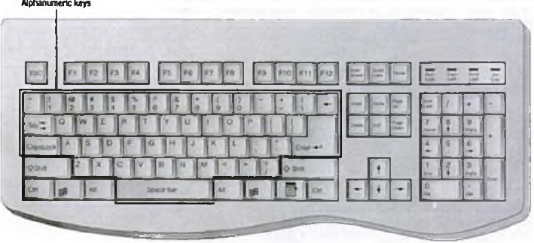

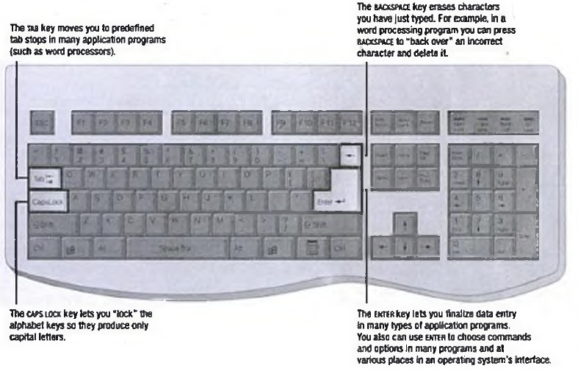

Figure 3A.2

For example, if you press the J key, you input a small letter/'. But if you hold down the shift key while pressing the J key, you input a capital /. Modifier keys are extremely useful because they give all other keys multiple capabilities.

**The Numeric Keypad**

The numeric keypad is usually located on the right side of the keyboard. The numeric keypad looks like a calculator's keypad, with its 10 digits and mathematical operators (+, -, *, and /). The numeric keypad also features a NUM LOCK key, which forces the numeric keys to input numbers. When NUM LOCK is deactivated, the numeric keypad's keys perform cursor movement control and other functions.

When pressed along with an alphanumeric key, shift forces the computer to output a capital letter or symbol sun is also a modifier key in some programs; for example, you can press shift along with cursor-movement keys to select text for editing.

**The Function Keys**

The function keys, which are labeled F l, f l, and so on, are usually arranged in a row along the top of the keyboard. They allow you to input commands without typing long strings of characters or navigating menus or dialog boxes. Each function key's purpose depends on the program you are using. For example, in most programs, F l is the help key. When you press it, a special window appears to display information about the program you are using. Most IBM-compatible keyboards have 12 function keys. Many programs use function keys along with modifier keys to give the function keys more capabilities.

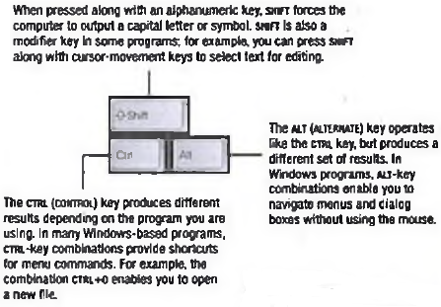

Figure 3A.3

**The Cursor-Movement Keys**

Most standard keyboards also include a set of cursor-movement keys, which let you move around the screen without using a mouse. In many programs and operating systems, a mark on the screen indicates where the characters you type will be entered. This mark, called the cursor or insertion point, appears on the screen as a blinking vertical line, a small box, or some other symbol to show your place in a document or command line.

**Special-Purpose Keys**

In addition to the five groups of keys described earlier, all IBM compatible keyboards feature six special-purpose keys, each of which performs a unique function. Since 1996, nearly all IBM-compatible keyboards have included two additional special-purpose keys designed to work with the Windows operating systems.

≫ Start. This key, which features the Windows logo (and is sometimes called the Windows logo key), opens the Windows Start menu on most computers. Pressing this key is the same as clicking the Start button on the Windows taskbar.

≫Shortcut. This key, which features an image o f a menu, opens an on-screen shortcut menu in Windows-based application programs.

One of the latest trends in keyboard technology is the addition of Internet and multimedia controls. Microsoft's Internet Keyboard and Multimedia Keyboard, for example, feature buttons that you can program to perform any number of tasks. For example, you can use the buttons to launch a Web browser, check e-mail.

figure 3A.4 1

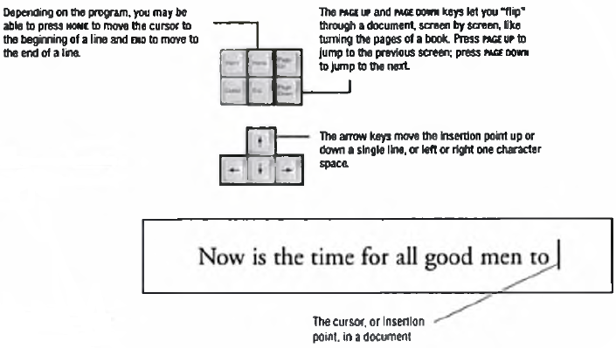

Figure 3A.5

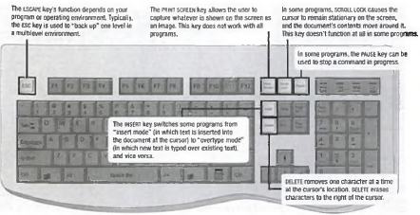

Figure3A.

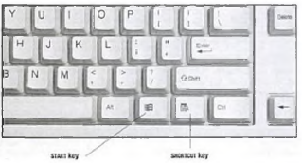figure3a.7

and start your most frequently used programs. Multimedia buttons let you control the computer’s CD-ROM or DVD drive and adjust the speaker volume. Many key board makers offer such features on newer models.

**How the Computer Accepts Input from the Keyboard**

You might think the keyboard simply sends the letter of a pressed key to the computer—after all, that is what appears to happen. Actually, the process of accepting input from the keyboard is more complex. When you press a key, a tiny chip called the keyboard controller notes that a key has been pressed. The keyboard controller places a code into part of its memory, called the keyboard buffer, to indicate which key was pressed. (A buffer is a temporary storage area that holds data until it can be processed.) The keyboard controller then sends a signal to the computer's system software, notifying it that something has happened at the keyboard.

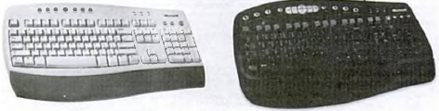 figure3A.8

Figure3A.9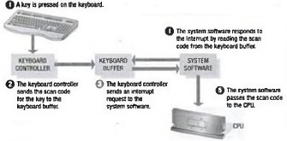

When the system software receives the signal, it determines the appropriate response. When a keystroke has occurred, the system reads the memory location in the keyboard buffer that contains the codes of the key that was pressed. The system software then passes that code to the CPU.

The keyboard buffer can store many keystrokes at one time. This capability is necessary because some time elapses between the pressing of a key and the computer’s reading of that key from the keyboard buffer. With the keystrokes stored in a buffer, the program can react to them when it is convenient. Of course, this all happens very quickly. Unless the computer is very busy handling multiple tasks, you notice no delay between pressing keys and seeing the letters on your screen.

In some computers, the keyboard controller handles input from the computer's keyboard and mouse and stores the settings for both devices. One keyboard setting, the repeat rate, determines how long you must hold down an alphanumeric key before the keyboard w ill repeat the character and how rapidly the character is retyped while you press the key. You can set the repeat rate to suit your typing speed.

**The Mouse**

A personal computer that was purchased in the early 1980s probably included a keyboard as the only input device. Today, every new PC includes a pointing device as standard equipment. Full-size PCs usually include a mouse as the pointing device. A mouse is an input device that you can move around on a flat surface (usually on a desk or keyboard tray) and controls the pointer. The pointer (also called the mouse pointer) is an on-screen object, usually an arrow, that is used to select text; access menus; and interact with programs, files, or data that appear on the screen. The mechanical mouse is the most common type of pointing device. A mechanical mouse contains a small rubber ball that pro- W trades through a hole in the bottom of the mouse’s case. The ball rolls inside the case when you move the mouse around on a flat surface. Inside the mouse, rollers and sensors send signals to the computer, telling it the distance, direction, and speed of the ball's motions. The computer uses this data to position the mouse pointer on the screen.

Another popular type of mouse, the optical mouse, is non mechanical. This type of mouse emits a beam of light from its underside; it uses the light's reflection to judge the distance, direction, and speed of its travel. The mouse offers two main benefits. First, the mouse lets you position the cursor anywhere on the screen quickly without using the cursor-movement keys. You simply move the pointer to the onscreen position you want and press the mouse button; the cursor appears at that location.

Second, instead of forcing you to type or issue commands from the keyboard, the mouse and mouse-based operating systems let you choose commands from easy-to-use menus and dialog boxes. The result is a much more intuitive way to use computers. Instead of remembering obscure command names, users can figure out rather easily where commands and options arc located.

If you use a drawing program, you can use the mouse to create graphics such as lines, curves, and freehand shapes on the screen. The mouse has helped establish the computer as a versatile tool for graphic designers, starting what has since become a revolution in the graphic design field.

**Using the Mouse**

You use a mouse to move the pointer to a location on the screen, a process called pointing. Everything you do with a mouse is accomplished by combining pointing with these techniques:

≫ Clicking

≫ Double-clicking

≫ Dragging

≫ Right-clicking

Pointing means pushing the mouse across your desk. On the screen, the pointer moves in relation to the mouse. Push the mouse forward, and the pointer moves up. Push the mouse to the left, and the pointer moves to the left. To point to an object or location on the screen, you simply use the mouse to place the pointer on top of the object or location.

The mice that come with IBM-compatible computers usually have two buttons, but techniques such as clicking, double-clicking, and dragging arc usually carried out with the left mouse button. In multibutton mice, one button must be designated as the “primary” button, referred to as the mouse button. Some mice can have three or more buttons. The buttons' uses are determined by the computer's operating system, application software, and mouse-control software. To click an item with the mouse, you move the pointer to the item on the screen. When the pointer touches the object, quickly press and release the primary mouse button once. Clicking—or single-clicking, as it is also called—is the most important mouse action. To select any object on the screen, such as a menu, command, or button, you click it. Double-clicking an item means pointing to the item with the mouse pointer and then pressing and releasing the mouse button twice in rapid succession. Double- clicking is primarily used with desktop objects such as icons. For example, you can double-click a program's icon to launch the program.

Dragging an item means positioning the mouse pointer over the item, pressing the primary mouse button, and holding it down as you move the mouse. As you move the pointer, the item is “dragged” along with it across the screen. You can then drop the item in a new position on the screen. These techniques are also called drag-and-drop editing, or just drag and drop. Dragging is a very handy tool. In a word processing program, for example, you can drag text from one location to another in a document. In a file-management program, you can drag a document's icon and drop it onto a printer's icon to print the document.

Windows and many Windows programs support right clicking, which means pointing to an item on the screen, then pressing and releasing the right mouse button. Right-clicking usually opens a shortcut menu that contains commands and options that pertain to the item to which you are pointing.

A wheel mouse has a small wheel nestled among its buttons. You can use the wheel for various purposes, one of which is scrolling through long documents. Not all applications and operating systems support the use of the wheel.

**Mouse Button Configurations**

The mouse usually sits to the right of the keyboard (for right-handed people), and the user maneuvers the mouse with the right hand, pressing the left button with the right forefinger. For this reason, the left mouse button is sometimes called the primary mouse button. If you are left-handed, you can configure the right mouse button as the primary button. This configuration lets you place the mouse to the left of the keyboard, control the mouse with your left hand, and use your left fore finger for most mouse actions.

Newer mice enable you to configure buttons to perform different tasks than clicking. You might configure a button to delete selected text, for example or to open a program that lets you search for files. Such settings may limit the usefulness of the mouse but can be helpful if you need to perform a certain task many times.

**Variants of the Mouse**

Although the mouse is a handy tool, some people do not like using a mouse or have difficulty maneuvering one. For others, a mouse requires too much desktop space a real problem when you are not working at a desk!

For these reasons and others, hardware makers have developed devices that duplicate the mouse's functionality but interact with the user in different ways. The primary goals or these “mouse variants'* are to provide case of use while taking up less space than a mouse. They all remain stationary and can even be built into the keyboard.

**Trackballs**

A trackball is a pointing device that works like an upside-down mouse. You rest your index finger or thumb on an exposed ball, then place your other fingers on the buttons. To move the pointer around the screen, you roll the ball with your index finger or thumb. Because you do not move the whole device, a trackball requires less space than a mouse. Trackballs gained popularity with the advent of laptop computers, which typically are used on laps or on small work surfaces that have no room for a mouse. Trackballs come in different models, as shown in Figure 3A.24. Some trackballs are large and heavy with a ball about the same size as a cue ball others are much smaller. Most trackballs feature two buttons, although three-button models are also available. Trackball units also are available in right- and left-handed models.

**Trackpads**

The trackpad (also called a touchpad) is a stationary pointing device that many people find less tiring to use than a mouse or trackball. The movement of a finger across a small touch-sensitive surface is translated into pointer movement on the computer screen. The touch-sensitive surface may be only 1.5 or 2 inches square, so the finger never has to move far. The trackpad's size also makes it suitable for a notebook computer. Some notebook models feature a built-in trackpad rather than a mouse or trackball.

Like mice, trackpads usually are separate from the keyboard in desktop computers and are attached to the computer through a cord. Some special keyboards feature built-in trackpads. This feature keeps the pad handy and frees a port that would otherwise be used by the trackpad.

Trackpads include two or three buttons that perform the same functions as mouse buttons. Some trackpads arc also “strike sensitive," meaning you can tap the pad with your fingertip instead of using its buttons.

**Pointers in the Keyboard**

Many portable computers now feature a small joystick positioned near the middle of the keyboard, typically between the G and H keys. The joystick is controlled with either forefinger, and it controls the movement of the pointer on screen. Because users do not have to take their hands off the keyboard to use this device, they can save a great deal of time and effort. Two buttons that perform the same function as mouse buttons are just beneath the spacebar and are pressed with the thumb. Several generic terms have emerged for this device; many manufacturers refer to it as an integrated.

**Productivity Tip**

**Saving Time With Keyboard Shortcuts**

In the 1980s, as programmers began packing more features into PC software, they also developed ways for users to issue an ever-increasing number of commands. Software packages came with long lists of commands, all of which had to be entered at the keyboard. (This was before the mouse came into common use.) As a result, the computer keyboard rapidly became a valuable tool.

Programmers began devising keyboard shortcuts that allow users to issue commands quickly by typing a short combination of keystrokes. Keyboard shortcuts involve using a modifier key (such as alt or ctrl.) along with one or more alphanumeric or function keys. To print a document in many applications, for example the user can press ctrl+p.

Function keys also became important The Fl key, for example, became the universal way to access online help. IBM compatible computer keyboards originally had 10 function keys; eventually the number of function keys was expanded to 12.

Another common type of keyboard shortcut involves pressing the alt key to access a program's menu system. When running any Windows program, you can press alt to activate the menu bar, and then press a highlighted letter in a menu's name to open that menu.

Still a keyboard can hold only so many keys, and the lists of keyboard shortcuts became unmanageable. A single program could use dozens of "hotkeys,” as these shortcuts were called. If you used several programs, you had to learn different shortcuts for each program. Finally, the Common User Access (CUA) standard led to the standardization of many commonly used hotkeys across different programs and environments. With this standard for commonly used hotkeys, users have fewer hotkeys to remember.

Despite such standards, pointing devices (such as the mouse) came along none too soon for hot key-weary computer users. Microsoft Windows and the Macintosh operating system gained popularity because of their easy-to-use, mouse-oriented graphical interfaces. By operating the mouse, users could make selections visually from menus and dialog boxes. Emphasis rapidly began shifting away from the keyboard to the screen; today, many users do not know the purpose of their function keys! Pointing device, while others call it a 3-D point stick. On the IBM ThinkPad line of notebook computers, the pointing device is called the Track Point .

**Ergonomics and Input Devices**

Any office worker will tell you that working at a desk all day can be extremely uncomfortable. Sitting all day and using a computer can be even worse. Not only does the user's body aches from being in a chair too long, but hand and wrist injuries can result from using a keyboard and mouse for long periods. Eyes can become strained from staring at a monitor for hours. Such injuries can be extreme, threatening the user’s general health and ability to work.

Much is being done to make computers easier, safer, and more comfortable to use. Ergonomics, which is the study of the physical relationship between people and their tools—such as computers— addresses these issues. Now more than ever before, people recognize the importance of having ergonomically correct computer furniture and using proper posture and techniques while working with computers. (The term ergonomically corrects means that a tool or a workplace is designed to work properly with the human body, and thus reduces the risk of stain and injuries.)

Pointing, however, can slow you down. As menus and dialog boxes become increasingly crowded, commands can be hard to find and their locations can be as difficult to remember as keyboard shortcuts. Many computer users overcome problems by using a combination of keyboard shortcuts and a pointing device. You use one hand to issue many basic shortcuts (such as CTRL+P and CTRL+s) or to launch macros. A macro is a series of commands that a program memorizes for you. Macros enable you to issue an entire set o t commands in just a few keystrokes. Using these techniques minimizes keystrokes and leaves a hand free to use a pointing device.

**Repetitive Stress Injuries**

The field of ergonomics did not receive much attention until a certain class of injuries began appearing among clerical workers who spend most of their time entering data on computer keyboards. These ailments are called repetitive stress injuries (RSIs) or repetitive strain injuries and result from continuously using the body in ways it was not designed to work. One type of RSI that is especially well documented among computer users is carpal tunnel syndrome, a wrist or hand injury caused by using a keyboard for long periods of time.

The carpal tunnel is a passageway in the wrist through which nerves pass (see Figure 3A.28). In carpal tunnel syndrome, tendons in the tunnel become inflamed because the victim has held his or her wrists stiffly for long periods, as people tend to do at a keyboard. When the tendons become inflamed, they press against the nerves, causing tingling, numbness, pain, or the inability to use the hands. Carpal tunnel syndrome is the best-known repetitive stress injury. It can become so debilitating that victims can miss weeks or months of work. In extreme cases, surgery is required.

**Avoiding Keyboard-Related Injuries**

If you use a computer frequently, you can avoid RSIs by adopting a few good work habits, and by making sure that your hardware and workspace are set up in an ergonomically friendly way.

**At Issue**

**Computer Voting—Is It a Good Thing?**

The dispute over electronic voting is as heated as a debate between presidential candidates. The risks versus the benefits are discussed, investigated, and argued. But what are the facts that lie beneath the fuss?

The key function of an electronic voting system is to obtain voter preferences and report them—reliably and accurately. Some assert that electronic systems are safer than other methods of voting because they implement security checks and audit trails, and are tougher to tamper with than paper ballots.

One of the most widely used electronic voting systems. Diebold Election Systems <http://www.diebold.com/> dieboldes/accuvote_ts.htm), boasts some 33,000 voting stations in locations across the United States. Diebold’s AccuVote-TS system is a voter activated interactive touch screen system using an intelligent Voter Card as the voter interface. The interface allows voters to view and cast their votes by touching target areas on an electronically generated ballot pad.

Each unit provides a direct-entry computerized voting station that automatically records and stores ballot information and results. While classified as a direct record entry (ORE) device, the AccuVote-TS system has additional capabilities. The tabulator is a multifunctional interface that counts and tabulates the ballots at precincts on Election Day and communicates with the host computer at Election Central for accurate and timely jurisdictionwide results.

However, electronic voting systems have generated concern because their work is not readily accessible for inspection; what goes on behind the screen is a mystery to the general public and therefore causes uneasiness. With computer voting, voter records are intangibly stored on a hard drive, with voting results recorded in electronic memory.

Indeed, a July 2003 analysis of the Diebold touch screen by computer researchers from Johns Hopkins and Rice universities (found at http://www.newscientist.coin) showed that the software was riddled with errors and open to fraud. However, even with the possibility of fraud, electronic.

When setting up your computing workspace, make it a priority to choose a comfortable, ergonomically designed chair. Your office chair should

≫ Allow you to adjust its height.

≫ Provide good lower-back support.

≫ Have adjustable armrests.

Your desk also should be well-suited to computer use, like the one. The desk should hold your keyboard and mouse at the proper height, so that your hands are at the same height as your elbows (or a few inches lower) when you hold them over the keyboard. Here are some other tips that can help you avoid RSIs while working with your keyboard and mouse:

≫ Use an Ergonomic Keyboard.

Traditional, flat keyboards are not well-suited to the shape of human hands. An ergonomic keyboard allows you to hold your hands in a more natural position (with wrists straight, rather than angled outward) while typing.

≫ Use a Padded Wrist Support. If you type a lot, a wrist support can be helpful by allowing you to rest your hands comfortably when you are not actually typing.

Remember; however, that systems may still be safer than prior methods of voting because they implement redundant security checks and audits and may be more difficult to tamper with because of the size and nature of their tabulating components. Another argument in favor of paper ballots, or at least paper receipts, is that in order to verify an election, all you need to do is gather up the ballots and tabulate them a second (or third, as the case may be) time. However, auditing paper ballot systems is not always as easy as it sounds. Ballots, particularly punch-cards, sometimes provide ambiguous results, as seen in a recent presidential election. They are easily forged and they must be physically handled and transported, which provides the opportunity for substitution or loss.

Whether computerized or traditional, no election system is infallible, and in truth, perhaps it doesn't need to be. As some have said, every safe has the capability to be cracked. The same is true for voting systems. The issue is not whether they are 100 percent secure, but whether they present adequate safeguards to give us faith in the integrity of our elections. you should never rest your wrists on anything—even a comfortable wrist support—while you type. Use the support only when your fingers are not moving over the keyboard.

≫ Keep Your Wrists Straight. When typing, your hands should be in a straight line with your forearms, when viewed either from above or from the side. Keeping the wrists bent in either direction can cause muscle fatigue.

≫ Sit Up Straight. Avoid slouching as you type, and keep your feet flat on the floor in front of you. Avoid crossing your legs in front of you or under your chair for long periods.

≫ Learn to Type. You will use the keyboard more efficiently and naturally if you know how to type. If you hunt and peck," you are more likely to slouch and keep your head down while looking at rite keyboard. This technique not only slows you down, but it leads to fatigue and stiffness.

≫ Take Frequent Breaks. Get up and move around for a few minutes each hour, and stretch occasionally throughout the day.

**Summary**

≫ A standard computer keyboard has about 100 keys.

≫ Most keyboards follow a similar layout, with their keys arranged in five groups. Those groups include the alphanumeric keys, numeric keypad, function keys, modifier keys, and cursor-movement keys.

≫ When you press a key, the keyboard controller places a code in the keyboard buffer to indicate which key was pressed. The keyboard sends the computer a signal, which tells the CPU to accept the keystroke.

≫ The mouse is a pointing device that lets you control the position of a graphical pointer on the screen without using the keyboard.

≫ Using the mouse involves five techniques: pointing, clicking, double-clicking, dragging, and right-clicking.

≫ A trackball is like a mouse turned upside-down. It provides the functionality of a mouse but takes less space on the desktop.

≫ A trackpad is a touch-sensitive pad that provides the same functionality as a mouse. To use a trackpad, you glide your finger across its surface.

≫ Many notebook computers provide a joystick-like pointing device built into the keyboard. You control the pointer by moving the joystick. On IBM systems, this device is called a Track Point Generically; it is called an integrated pointing device.

≫ Continuous use of a keyboard and pointing device can lead to repetitive stress injuries.

≫ the field of ergonomics studies the way people use took. This study leads to better product designs and techniques that help people avoid injuries at work.

≫ ergonomically designed keyboards are available to help users prevent repetitive stress injuries to the wrists and hands.